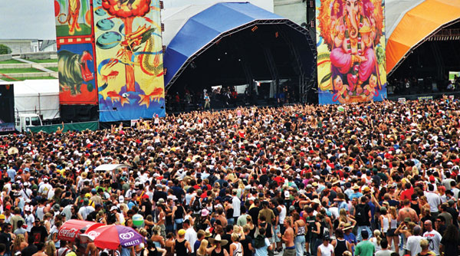

**A Music Festival App**

**Description**

The objective of this project is to take advantage of emerging and existing mobile technologies to develop a smart phone mobile application designed to be targeted towards the music festival market and the many fans who attend these festivals. To achieve these aims, this project will be implemented on Google’s Android operating system for use on the many Android devices currently available.

The application will provide a ‘festival-goer’ with many useful features; all designed to keep the user informed and prepared for attending a music festival as well as providing interactivity and social aspects to enhance their experience. The project will take on client- server architecture so a central server can send and receive relevant data to each client device.

**Requirements Engineering**

**Feasibility Study**

1. Are there apps similar to this in the marketplace (in Android, iOS, Windows …)?

Yes, there are.

1. In what ways do festival goers currently get their information?

From the festival website or social media sites of the festival and other festival goers.

1. Who are the stakeholders? Would this app affect them positively or negatively?

The stakeholders are people who would like to provide festival goers with an app that would enhance their experience at the festival. This app would affect them positively as they would be making a profit (E.g. allowing ads to be displayed in the app).

1. What other research would be necessary to ascertain feasibility e.g., ownership of smartphones …?

A survey that determines what OS that the app should be made for. Another method is to ask potential users what they would like to use the app for, such as sharing photos taken at the festival.

1. Make an initial list of **functional** and **non-functional** requirements.

**Functional**

1. User friendly interface.
2. Ability to edit the user profile and what the user has posted.
3. Weather checking.
4. Performance line-up and times.
5. Map of the festival grounds.

**Non-functional**

1. Fast response time.
2. Appropriate storage requirements.
3. Automatic backup of the data.
4. Security.
5. Recovery time.

**Requirements Elicitation**

1. Could ethnographic methods be used in this case study? If so, in what way?

Yes. The potential users can be observed while they are attending a festival. This way, the developer can determine the needs of the user.

1. Identify a significant stakeholder(s), which will be **interview**ed to get more information on the intended product. Justify your choice of stakeholder(s). Do up an interview plan and pre-prepare approximately10 questions.

Facebook. This choice is because they are the biggest social media site with more than a billion active users.

1. Will the users be able to link their Facebook profiles to the app?
2. Will the app have the familiar layout of the Facebook app or will it have a new design?
3. Will the app cost anything to download?
4. Are there in-app purchases available? (e.g. filters for photos that the user might upload)
5. Will the users have a choice when creating posts to share them to their other social media sites? (i.e. linking other social media accounts to this app)
6. Will there be ads within the app? If so, will the ads disrupt the experience of using the app?
7. Will the app be OS specific?
8. Will the app be customizable to fit the users’ needs?
9. Will users be able to post videos or text in addition to photos?
10. Is in-app messaging available?
11. Identify a significant group of stakeholders, which will receive **questionnaires**. Justify your choice of stakeholders. The questionnaire should have approximately 10 questions.